Chapter 22
Oakridge Community Resource Unit

Section One:

Baseline Social and Economic Information

Community Description

Geographic Features

The Oakridge CRU stretches from the crest of the Cascades on the east, to south of the South Fork of the McKenzie on the north, to between Westfir and Lookout Point Lake on the west, to south of Hills Creek Lake on the south. It includes the community of Westfir. Figure 64 shows a map of the unit.

Settlement Patterns

Oakridge had 3257 people in 1990 and 3148 in 2000, a decline of 4%. Westfir had 289 people in 1990 and 276 people in 2000, a decline of 5% (Census Data, Table Seven).

Oakridge is divided into two halves with the railroad being the divider. The majority of housing lies on the north side of the tracks and the Willamette River is on the south side. The town is wedged into the valley that the river carved. Highway 58 is extremely busy and dangerous because of the high capacity of logging trucks that pass through. Oakridge is the last town before reaching the Willamette Pass ski area and summit of the Cascades.

Oakridge used to be “uptown” off of Highway 58, but the core of the community is slowly shifting to the highway.

“Now, everything is oriented to Highway 58 to get the car traffic.”

Figure 64
Map of the Oakridge Community Resource Unit
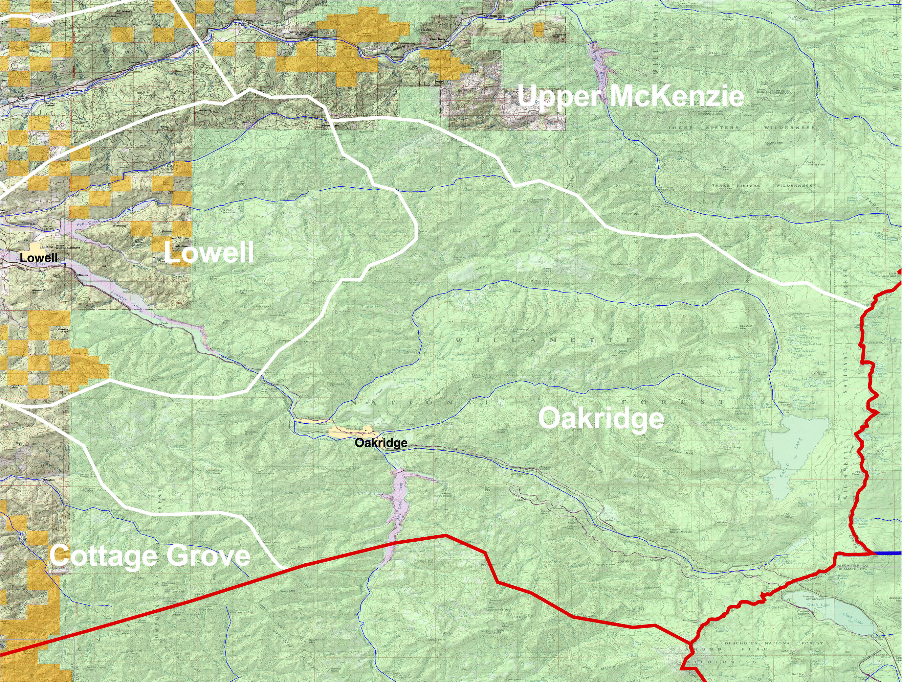

Figure 65
Bridge over the Willamette River near Oakridge
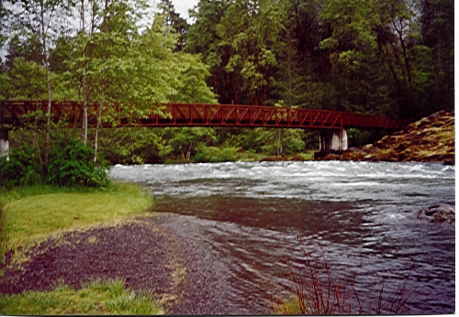

“I used to live in the ghetto area along the railroad tracks. We liked it.”

“We came here four years ago to retire because we liked the climate and the beauty. We’ve been well received.”

“The natural beauty and cheap housing attracted me here 8 years ago.”

“I stay here because it is quiet and peaceful, for the most part.”

“We moved to Eugene as a kid because my family could not make it here. We moved back when we could. That was the pattern.”

Publics

Residents report that the town is becoming a bedroom community, “but not too much.” Although the flow of people between Oakridge and Eugene has been a fact of life for generations, more people are commuting today for their livelihood. However, this pattern is not nearly as pronounced as in other parts of the Cascades. One observer pointed out that residents of Detroit, Sweet Home, and even McKenzie Valley have a range of urban zones to which they have access, while Oakridge residents, in practical terms, can only get to Eugene and Springfield. This factor may be limiting the commuting phenomenon so prevalent in the other areas.

A number of people pointed to the increase of low-income residents that have come to the community in the last ten years. The perception is that the attraction is affordable housing available in Oakridge. However, the new welfare reform act evidently is encouraging their return to the urban area because of its requirements to seek out work. As it is, the flow of these folks into and out of the community continues.

“There are more low income people living on welfare here now. They come here for the affordable housing.”

Local residents estimated retired people in the community at about 50%.

Other publics include forest industry workers, business people, families, and youth. We were told the only Hispanics in town run the Mexican restaurant.

Networks

See Section Two.

Work Routines

The decline of timber production has hit this community hard. Several boarded up businesses, and many homes in need of renovation attest to the poor economic conditions that characterize the area presently. Perhaps half of the housing stock is trailer homes. The city planner stated that the population went from 5000 to 3000 in a short period of time.

“People gave up on timber. Forest products has only one line in the economic strategy group.”

“Fallers commute four hours now instead of one. They can come back if things open up.”

“Clearcuts are good for hunting, Christmas trees and firewood. These are part of our culture.”

“I’ve worked all over the valley—mostly trucking logs out of the forest. I have a trailer in Oakridge because it is twice as cheap as living in Eugene.”

The city is actively working to bring in new business and, like other Oregon communities, has focused on recreation as the most promising area of development. Oakridge is beginning to bill itself as the “Center of Oregon Recreation.” Outdoor stores are needed to promote skiing, mountain biking, and boating. Only one fly shop is in town. A marketing company has been hired to create a new trademark for the community, to market prospective businesses, and to develop a web page for Oakridge. A new pizzeria opened during the research period that was packed on opening night.

Residents stated that ski shops and bike shops don’t go over well because of the long off-season. The rent is too high for these businesses. Poor snow conditions in the last few years make it difficult as well.

A number of new businesses have begun in the area, including childcare, foster care, and special needs care. Creative Composites is a new plastics manufacturer. Kozy Kamper is manufacturing facility at the Industrial Park. Many residents talked about the loss of the Armstrong mill, which after receiving much support from city, the Forest Service, and the community, is moving to Klamath Falls, “for a better deal.”

The City Administrator reported that the major employers important for Oakridge residents, along with the number of their employers, are:

Oakridge School District, education 110
Middle Fork Ranger District, Forest Service 97
Armstrong Wood Products, secondary wood products 42
Ray’s Food Place, grocery store 39
City of Oakridge, government 32
Source: Oregon Department of Economic and Community Development, Community Profiles, 2000.

Support Services

When residents were asked about their community, they typically listed businesses that were no longer present—so many food stores, bars, restaurants and other businesses. These businesses could not survive after the decline of timber.

“Over 20 businesses have gone down.”

The City’s “dark period” was between 1999 and 2001. The city almost went bankrupt and the town became fragmented. The two newspapers were “feuding”, and drawing residents into protracted political fights that remained unresolved. Some people attempted to start another Chamber of Commerce to circumvent the existing one.

The Chamber of Commerce has been inactive for the past couple years. Although it was near bankruptcy, it maintained a minimal presence. School enrollments are said to be declining steadily. Officials are considering merging the middle and high schools.

“The school superintendent is leaving because he said he couldn’t carry the load anymore. This area lacks volunteer efforts. The elementary school principal is leaving as well.”

“Kids are coming to school dirty.”

Greyhound quit stopping in town a couple years back. Only seniors and disabled people have public transportation into town. The railroad downsized a couple years ago.

The City is attempting to re-orient its activities to support a recreation economy. “The City is not in the business of managing recreation,” the city planner said, and must develop its capacity. Several people commented that the new city administrator was a “breath of fresh air” and was likely to create more positive outcomes.

A town meeting held in April was said by one resident to be the first one held to talk about the future of Oakridge. Residents expressed hope that that meeting would create momentum and agreement about vision and direction.

The water system needs to be upgraded as the sewer system floods every time it rains. The industrial park was established and money put into it, but now the community is wondering what’s going to happen next. Second Street is in very bad shape. The city wishes to hire an economic development person.

“Truckers favor Highway 58 over I-5 [Interstate 5] because they don’t have to chain up so often. The City could take advantage of this somehow.”

The Willamette Activity Center houses the social service offices in town. Many of the offices do not open until 1 p.m. Oakridge houses a learning center from Lane Community College that conducts customized training programs in conjunction with Oregon Economic and Community Development Department.

Collaborative events in the community mentioned by residents are Oakridge/Westfir Together, a coalition against tobacco, alcohol and drugs, and the annual Halloween Party, with 500 people attending last year. The Tree Planting Festival, begun in 1953, is still very well attended by visitors and residents. Other community events include the Aufderheide Road Tour, Pioneer Picnic, the Cascade Fat Tire Festival, The Cream Puff Bicycle Race, the fall production of the Zero Clearance Theatre Company, Westfir Bridge Lighting, and Oakridge Holiday Decoration

Over 230 Food Baskets went to seniors this year, indicating a strong caretaking system that is still operating.

Recreational Activities

See Section Three.

Trends, Themes and Citizen Issues

Related to Community Life

Trends

The percentage of low-income residents is increasing because of the availability of affordable housing.

Young families are leaving to find work elsewhere.

Oakridge is turning into a bedroom community.

Young retired people move to the area, and then move away as they age when they need better medical services or assisted living care.

After several difficult years, there are signs of renewed energy and leadership in the community.

Themes

1. “The biggest thing has to do with getting over the timber boom. People can’t stop talking about trying to get timber back in town.”

“I miss the good old logging days.”

2. “This area is in a downward spiral. Why invest?” This comment reflects the general pessimism expressed by several residents about the business climate in Oakridge.

3. “We don’t say ‘no’.” A number of city staff described the open door policy that they attempt to ensure, encouraging people to come in and talk.

“We want the family atmosphere that we had ten years ago—the sense that we’re all in this together and we have to make it work.”

4. “We are becoming a volunteer community.” Residents said that before 1988, there was money in the town. After the timber bust, the residents who didn’t leave began to volunteer for civic affairs in the face of shrinking budgets. This theme reflects the belief of many that Oakridge has an emerging spirit and energy for change.

“___ operated a skating rink for the kids. Most came in for free in return for chores to keep it going. Almost every weekend, she had sleepovers at the rink. She didn’t make money and didn’t want to. When the rent doubled she quit. Most nights, there were 150 kids at the rink.”

Citizen Issues Related to Community Life

City Governance

“ODOT wants to do everything cheap and fast. The City is trying to revitalize, plant new trees, pave sidewalks, and fix streets. We have a long-term perspective and ODOT is an obstacle.”

“We need to figure out what the public priorities are. The City has no idea how the public feels about certain things, how they would like to see things done.”

“Collaboration among the communities along Highway 58 was poor. They didn’t realize the benefit of networking.”

“The city bought all these trees and bushes for the downtown lot. They forgot about them and the plants almost died before they were planted. It’s an example of how the city works.”

“The city tried to make all home businesses pay double sewer tax because they were supposed to have two bathrooms. It made everyone mad and they gave it up.”

“The City has plans to bury the power lines. That’s too expensive and there are more immediate problems, like the need for a laundromat.”

Services

“Lane County is talking about consolidating 911 centers, merging Oakridge and Florence. There’s a lot of forest and highway to cover. Oakridge needs to have 24 hour service.”

“We’d still like to see the Chamber of Commerce to locate in the new Forest Service building.”

“I heard that Oakridge was going to get a laundromat soon. That would be a good thing because of all the trailer homes.”

“A sensible place to start with downtown is to paint the buildings.”

Quality of Life

“Many kids don’t want to leave Oakridge. They like living here, but they’re forced to leave because there are no jobs. I knew two boys a few years out of high school that left for Eugene but came back because they missed living here.”

“Highway 58 is dangerous and a speed trap. People don’t realize how slow they have to drive through town.”

“Highway 58 is a major eyesore. There are plans for possible curbs and tree planting alongside businesses.”

“Many high school kids have died on 58. It has a history of fatalities. Many people in town own a police scanner to hear about wrecks.”

“Kids have nothing to do. Drinking and drugs are a big problem. A new officer has been hired to track tends down that are partying in the woods.”

“Commuting takes a toll on the parents. They have less time for their kids.”

“I don’t want to talk with you. This is a very small community and I’d rather not say anything.”

Loss of Business and New Development

Residents bemoaned the loss of business during the last decade, from five video stores down to two, from two newspapers to one (although many people thought the loss of a paper was a blessing because of their feud). The number one issue expressed in the community was a wish for more economic activity.

“The newspaper feud splintered the community and it still hasn’t recovered.”

“A minimum security prison was interested in coming to town, but a vocal minority showed up to meetings and shut down the plans. That would have brought a lot of jobs to the area.”

“Since Armstrong is closing, the only jobs left are with the Forest Service and the schools.”

Section Two:

Communication Strategies

A. Informal Networks and Communication

Visitors use McGillicuddy’s coffee shop and deli.
The bulletin board at the Metro Credit Union is regularly used.
Long time residents and loggers gather at the Village Café.
True Video is a communication spot.
The bowling alley is frequented by seniors, drinkers and smokers and is very often packed.
Rosalina’s café is an important gathering place for mountain bikers that use the Oakridge area.

B. Formal Groups and Communication

Figure 66

Organizations With Interest in Public Lands in the Oakridge Area

Organization | Contact Information | Mission
Oakridge/Westfir Chamber of Commerce | 48248 Highway 58  Oakridge, OR  (541) 782-4146 | Business development
Lost Creek Watershed Group | Diane Davis  P.O. Box 27  Lowell OR 97452  mailto:mfwwc@efn.org  (541) 937-9800 | Watershed restoration
Mid-Fork Willamette Council | Juan Welsh  P.O. Box 27  Lowell, OR 97452  (541) 937-9800  mfwwc@efn.org | Watershed restoration

Section Three:

The Public Lands Perspective

A. Uses of and Orientation to Public Lands

Part of the recreation interest of Oakridge families is for positive outlets for kids and adolescents. The general sentiment is that young people do not have enough to do (See Issues section). As families have reverted to commuting, time available for family life has decreased, so that kids and youth are more unsupervised than previous years.

Skating and movies are not enough for kids. They go to Eugene for entertainment.”

Oakridge residents are very oriented to the outdoors and to public lands. In the past, that orientation has mainly revolved around the timber industry and the needs of a working population. While recreation is increasingly important in an economic sense, recreation activities for long-time residents remain traditional—fishing, hunting and hiking, with winter sports coming into its own. The area is heavily used for snowmobiling in the winter, although presently not many businesses are oriented to the activity.

Mountain biking has become very popular around Oakridge. Mountain bike stores and enthusiasts in Eugene talked about the efforts they have made to build mountain bike trails in Oakridge and maintained that Oakridge is the favorite area in the region for the sport. Mountain bike people made a point of stating that they cater to certain businesses in Oakridge that they feel appreciate their presence. Overall, they did not feel that Oakridge is oriented to them or to their economic contribution.

Boat launches will be built soon, according to a couple locals. The economic development related to recreation has not been developed.

“We are an area of dispersed users—fly fishers and bikers, for example. They don’t spend.”

Forest Service partnerships in this area are many but include:

- Youth Conservation Corps (YCC) with high school kids;
- Outdoor School through the Oakridge School District;
- Volunteer Day;
- Youth engaged in community service;
- The Middle School is working with the Forest Service on a trails program;
- Forest Service staff serve in various capacities in the community from boards of various organizations (school board, city council) to teaching wrestling.

The agency also aided the development of the industrial park, which has had limited success so far. The Family Resource Center is housed in the Oakridge Elementary School. It offers a variety of classes for all groups in computer, art, writing, literacy, and other topics. The Forest Service has assisted this organization in many ways, including involving youth to put together an informational book on Waldo Lake, paint a mural on the new Forest Service building, and contribute art work to its lobby.

B. Themes and Citizen Issues Related to

Natural Resource Management

Themes

1. “People respect Forest Service employees, but there is still bitterness about the loss of timber.” This theme appeared widespread and relates to generally positive relationships between Forest Service workers and town residents. The anger about timber policy is more generalized, attributed to the national level and to “environmentalists.”

“I have nothing but good things to say about the Forest Service. Many of them are my friends. They are doing a great job.”

2. “We love what we do, but the economics has not caught up. We are losing ground.” There is an inherent resilience and determination in Oakridge at the individual level that has not yet reached critical mass. The emerging economic strategies have not yet taken hold enough to get people from the edge of survival into more comfortable positions.

3. “We don’t know what the rules are anymore.” Forest Service staff expressed this theme in relation to the great number of changes that have taken past over the last several years. It reflects the great uncertainty since timber production has declined but new answers have not yet emerged. Timber sales, reduced in volume and number, are offered but not sold; gridlock occurs in relation to other initiatives. How best to help the community in its transition is not always clear or agreed to by others.

“People have lost trust with the Forest Service. They perceive we lost the mill, put in the fee demos, had problems with survey and management; now there are road closures.”

Citizen Issues Related to Natural Resource Management

General

“If the Forest Service loses anymore staff, or if they close another office, how are they going to manage their lands? There is so much land out there.”

Jobs and Business

“I hear the Forest Service is going to lay off a lot more people. That makes me really nervous. I also heard the Armstrong mill is going to close down—that’s another 30 people out of a job.”

“Fifty jobs are going to be lost when Armstrong moves to Drain. The City gave them tax breaks and incentives, but I guess they found a sweeter deal.”

“Jobs in the Woods [training program] has been good but not sustainable. It is still dependent on funding.”

“We were offered $12,000 to restore the mill site, but no one has equipment. It’s a steep site. We turned it down.” [Forest Service staff]

“Working on the summer crews as a high school kid was part of the culture of Oakridge. Now there aren’t many of those jobs and you have to know someone to get them.”

Recreation

“The road closure policy is a good one. The forest needs a breather for a while. You can still hike in.”

“Road closures are good during hunting season because it limits the poaching. It’s harder on older hunters, though, who can’t walk far distances.”

“Every time I go out to hunt, there are more roads closed. It’s very frustrating because we don’t know which roads are going to be closed until we are in the woods. So much of the mountains are no longer accessible because the roads leading up to them are closed. Road 2104 is especially a loss. It’s closed because of a slide, but it probably won’t get cleared.”

“Everyone says after 9/11 that we’ll see more car visitors, but how will we handle them is access is limited? A lot of mountain bikers come to Oakridge. They are impacted by road closures and poor maintenance.”

“How will fires be handled if crews can’t get to the them?” [an access concern]

“The Forest Pass is not right. We all pay taxes to use public land. There needs to be exceptions for certain things.” [This issue was mentioned many times and many of the stores had ‘Just Say No to USDA Forest Pass.’]

“The Forest Service should fix the big crack in the Packard boat launch at the reservoir. The road needs to be swept more often.”

“We had people wanting to fix up Crawford Hot Springs, but the Forest Service ran off people who volunteered to make the springs better. They said they couldn’t use tools to fix the area up.”

“The recreation person [of the Forest Service] has a narrow idea of what recreation is. If you don’t fit the mold, you’re out of luck.”

“The increased fees to hunt and fish have driven some people away. Many just can’t afford it.”

“A lot of my customers want a map showing land ownership. It’s very confusing and often changes. Something up to date.” [Sporting goods store manager]

City Concerns

The city planner had these ideas for Forest Service consideration:

- Bring the Rigdon trail into town, rather than east of town;
- Give the City “special use permits” to create recreational activities. In the past, the City has been turned down;
- Help to clear trails on Larison Rock for mountain biking and a chair lift. The hill lies at the base of town. Bikers could ride into town, and two bridges already provide access across the river.
- Keep the hot springs free of fees. Apparently, it is one of the last ones that don’t charge a fee. However, land around the springs could be developed for resort-like activities.
- The Rigdon work center could be turned over to the city to house public works.

C. Management Opportunities

Communication Opportunities

The language of residents is oriented to the industrial age—the commodity production of timber, the “Industrial Park” and so on, rather than to the emerging era of amenity migration, “modem cowboys”, and decentralized economic activity. The “big picture” of Oregon and the region suggests ongoing resettlement of scenic areas, including Oakridge, by: 1) young retired people bringing in capital and energy for family-based businesses; 2) global entrepreneurs who only need “UPS and an airport” to create home-based and web-based economic enterprises; and 3) service businesses catering to visitors and leisure time pursuits. Learning opportunities could be developed for Oakridge residents to explore current efforts at innovation in their community and others, to examine state and regional trends of which they could take advantage, and to develop the support functions necessary for successful adaptation.

It would be helpful for the District Office to undertake an internal “visioning” process for what it thinks it could effectively offer to aid community transition. It seemed to the JKA team that Forest Service people had a good understanding of the challenges in Oakridge, but very different ideas about the role of the agency. A clear vision should be followed by specific strategies to create “traction” on the ground with residents. There are many successes to build upon. However, the goal at this phase of transition would be to make “strategic choices”, that is, choices made with knowledge of limited resources and a clear knowledge of the opportunities, so that resources are maximized. Fundamental to the actions are those that build “social capital” in the community, so that the capacity of residents to work together again is enhanced.

Social mapping of key caretakers and communicators would be instrumental in helping the Forest Service deal with rumors, create traction for initiatives, and communicate effectively about Forest Service projects. Many staff have intimate knowledge of communication patterns. This information should be used systematically to create a broad-based approach to community contact. The goal should be citizen ownership of outcomes, generating momentum, and eliminating barriers, as called for in the Issue Management option in the section on Final Recommendations.

For certain initiatives, including those involved with timber and recreation, a community-based approach must include Eugene and Springfield. Again, social mapping of caretakers and communicators in the urban zones will help stabilize relations in the long-term, identify emerging issues for resolution, and build support for mutual initiatives over time.

Action Opportunities

The City planner is new to the area and has many good ideas. Further connection with the City could be appropriate.

The Forest needs to provide services and the infrastructure for a recreation economy, especially special use permits, so that entrepreneurs will stimulate economic activity.

Stimulate learning with other communities, notably Detroit, about orienting to a recreation economy. Find ways to fast track the learning necessary to foster entrepreneurial and support functions.

Provide outside expertise to the Forest Service and to the community in organizing for change by creating community-based partnerships.

This page intentionally left blank

